Areas of Learning |  | Autumn 1 | Autumn 2 | Spring 1 | Spring 2 | Summer 1 | Summer 2
 | Theme | Super Duper Me | I Wonder Why We Celebrate | Once Upon A Time | Adventurers and Heroes | All Things Big and Small | Our World
 | Super Six | 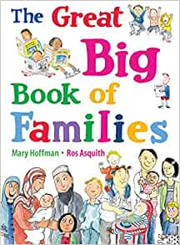  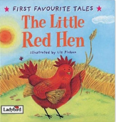  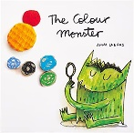  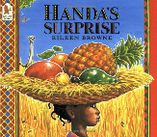  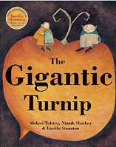  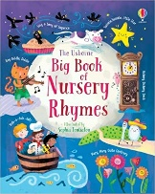 | 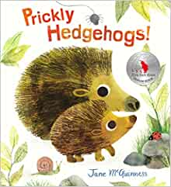  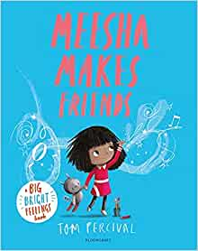  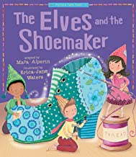    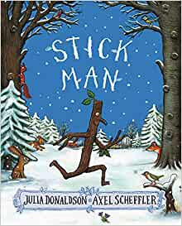  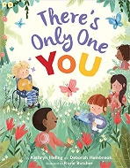 | 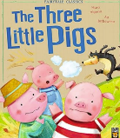  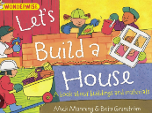      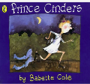   |     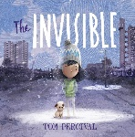  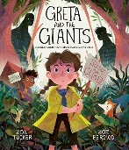    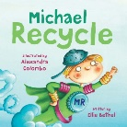 | 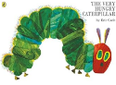  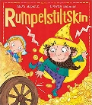  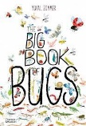    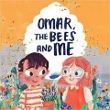  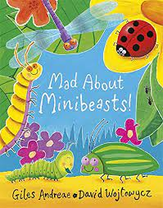 | 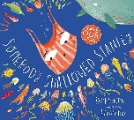  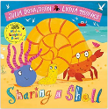  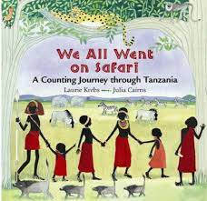  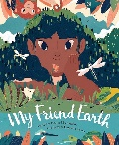  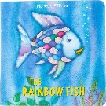  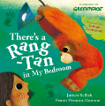
 | Family sessions and workshops | Tree of Significance  Phonics and Early Reading Workshop | Hedgehog Houses | Building a boat using different materials. | Occupation Discussions  Maths Workshop | Afternoon Tea with Someone Special | All about Me booklet to give to our new teacher.
 | Educational Visits | 1.Walk to the local shop to buy soup ingredients | 1.Walk to the post box (Letter to Santa)  2. Visit the local care home to sing Christmas Songs | 1. Walk to the local library | - Little City  - Local PCSO visit | - Wicken Fen | TBC
 | Wow Moments | 1.All About Me box  2.Meeting our Year 6 Buddy | 1.Self Portraits of our buddies  2.Bonfire Night  3.Diwali  4.Halloween  5.Nativity | 1.Whole School Bird Watch  2.Pancake Day  3.Testing our Boats with Our Buddies | 1.World Book Day  2.Science Week | 1.Earth Day  2.Observation of Life cycle of a Butterfly  3.Learn and Perform a Poem to Our Buddy | 1.Jump Up Morning to New Class.
 | Taught Sessions
Communication and Language | Weekly Crew Time  Weekly- Makaton Sign of the Week
PSED | Cambridgeshire PSHE  Scheme  (headings are from the scheme) | Myself and my Relationships |  | Citizenship  Healthy and Safer Lifestyles  Myself and My Relationships |  | Healthy and Safer Lifestyles RSE  Myself and My Relationships
PSED | Weekly Crew Time
Physical Development | PE (Gross Motor)  Scheme: Cambridgeshire | Listening games, boundary games e.g traffic lights  Dance  Unit-On Parade  ‘Moving with control’ | Dance  STEP: pathways  -Variety of movement  -Changing pace  -Dynamics-response to music | Gymnastics  Unit-Fun gym shapes  Expectations on moving on and around apparatus | Gymnastics  Unit- Move and hold | Listening games, boundary games e.g traffic lights (introduction to outdoor space)  Outdoor games | Outdoor  Games  Fundamentals Unit  -Sports day practice
Physical Development | Fine Motor | Responding to the Cohorts needs through weekly Morning activities and Fine Motor Station in the classroom  (Examples: playdough, scissor control, clay, painting, tweezers, loose parts, threading, mashers , Lego , weaving etc)
Literacy | Phonics | See Little Wandle Reception Progression
Literacy | English Writing texts |   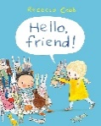 |    |   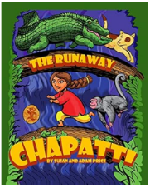   | 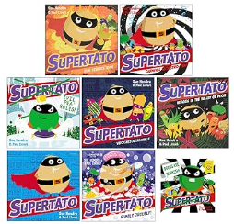  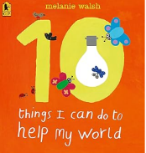 | 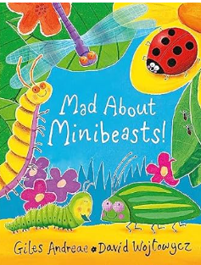  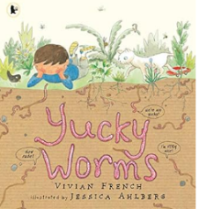  (performance of poem) | 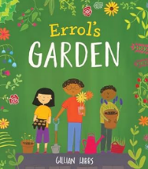  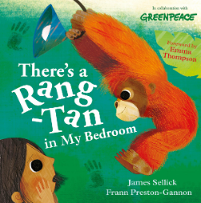
Literacy | Writing outcomes | Labelling a picture (initial sound)  Story Map- Editing/Changing the story (Video Narration) | Party Invite (Initial Sound- CVC words)  Story Map for next adventure (CVC words - Caption) | Story Map- What Happens next (Caption)  Writing repeated Refrains  (Caption- Simple Sentence) | Poster/List  (Caption- Simple Sentence)  Write a simple story about our own hero. (Caption-Simple Sentence) | Instructional Text (Sentence writing)  Recount of our Trip (Sentence Writing) | Instructional Booklet about gardening.  (Sentence writing)  Rhyme and repeated refrains (Sentence writing)
Literacy | Writing outcomes | Using known phonics  Spring 1- Summer 2 : Include tricky words matching phonic progression in captions and sentence writing
Mathematics | Scheme: Maths No Problem- See progression document  Supplemented and adapted using White Rose, NCTEM, NRich
Understanding the World | History | What has happened in my life so far? | Remembrance Day  Bonfire Night | History of the local Library | Adventurers Past and Present  Significant Individuals: Greta Thunberg |  | Who are the Year 1 Teachers and how are they significant to me?  Significant Individuals: David Attenburgh
Understanding the World | Geography | Harvest in the UK | How to help hedgehogs in an Urban environment | Buildings in our local environment | Adventurers and how they use maps  Sustainability | Earth Day | Physical and human features of UK and other Countries  Plastic pollution
Understanding the World | Geography | Seasonal Changes and Weather Discussed throughout the year
Understanding the World | RE  Scheme: Discovery RE | What makes people special  Sukkot | What is Christmas  Diwali  Hanukah  Advent | How do People Celebrate?  Chinese New Year | What is Easter | What can we Learn from Stories? | What Makes Places Special?
Understanding the World | Science | My Body  5 Senses  Oral Hygiene | Hibernating Animals | Material properties  Man-Made and Natural Materials  Floating and Sinking | Material Properties: Recycling | Mini Beasts  Life Cycle of a Butterfly | Animals on Land and sea  Dinosaurs and Fossils
Life Cycle of a flower

Parts of a Flower

Animals
Understanding the World | Computing |  |  |  | Explore Simple city and all of the different areas and occupations related to what we are looking at | Explore using Paint projects |  | Explore computing and coding area of Mini-Mash (leads on from using the bee-bots on the floor)
Understanding the World |  | Seasonal Changes and Weather Discussed throughout the year
Understanding the World | Forest School | Children attend Forest School all Year.  Please see Forest School Curriculum Pathway
Expressive Arts and Design | Music  Scheme : Charanga | Known Nursery Rhymes | Nativity Songs | Everyone! Unit | Our World Unit! |  | Big Bear Funk! Unit
Expressive Arts and Design | Music  Scheme : Charanga | Weekly KS1 Singing Assembly
Expressive Arts and Design | Art | Colour Mixing  Sculptures inspired by Guiseppe Archimboldo. | Seasonal tree painting  Mixed media painting for fire works  Diya Lamp making  Art inspired by Mondrian and Kadinsky. |  | Observational Drawing | Collaging with wax crayon Rubbings  Creating an insect Hotel | Mono Printing- Yayoi Kusama  Transient art
Expressive Arts and Design | DT | Food: Making Vegetable Soup | Hedgehog houses | Structures: Making a house for the Three Little Pigs |  | Beetbot- Programming and algorithm | Textiles: Sewing and joining a Rainbow Fish
Children have access to Continuous provision daily through protected time timetabled as COOL time. During COOL time enhancements are provided to support the learning during taught sessions.

