Learning Environments

# Elegance. Excellence. Exceptional.

Milton Road is a beautiful well-resourced and exceptional building. It is the responsibility of EVERYONE to keep it looked after and attractive and to maximise the indoor and outdoor space for academic and other outcomes.

All classrooms and corridors, group rooms and pod areas must be tidy, elegant and used purposefully. They should be welcoming for the children, tidy and organised to ensure learning is maximised and no time is wasted.

# Calm and Purposeful Organisation

Teacher resources must be stored carefully and neatly in group rooms or stored tidily in the classroom if needed regularly. Group rooms must be used as a break-out space for learning for all and not just used as storage. The space must be clutter-free and calm. All furniture in classrooms and group rooms should have a distinct purpose, centring on the learning needs of the children. Any excess furniture or resources should be removed.

Children’s workbooks should be labelled in boxes and stored neatly to allow for easy accessibility and distribution. Other resources should also be stored to offer children the freedom and choice to access tools to help them in their learning. Children must take responsibility for their own (and classroom) resources, understanding that everything needs to be in its place and cared for responsibly.

Reading is promoted through a designated book area/reading corner which will be in the learning corridor (KS2) and also in the classroom. Books should be refreshed (at least) termly from the school library with topic related books regularly updated to support learning.

# Lost Property

Lost property must be kept to a minimum. To ensure this, there should be regular opportunities in the classroom to re-unite children with their possessions and left lost property disposed of sustainably by the teacher or TA. There is no central lost property area.

Everyone must implement “Look Back Check” to ensure property is picked up and areas e.g. the library are left exactly as found, including chairs pushed under and resources returned to where they were collected from. Cloakrooms must be kept tidy and children given strategies to take responsibility for this.

# Displays and Working Walls

Working walls for English and Maths should be, as much as possible, at the front of the classroom for accessibility; associated resources should be stored close by and linked in presentation to the colour scheme of the relevant working wall.

Blue tac must not be used on walls. Displays must only be on agreed display boards. External and Internal windows must be kept clear, with no displays or resources stuck on them.

Displays are to celebrate different aspects of the curriculum, ensuring the presence of high quality writing in the classroom and a balance of writing/maths and other subjects in whole school displays.

Hessian should be used as a background for displays, ensuring a natural finish to the environment. Neutral tones, with ‘pops’ of colour should form the colour scheme for classrooms and corridors. Please refer to *Display Non-Negotiables Appendix 1*.

# Crew

The curriculum organisation, pedagogy and relationship and behaviour policy empathise the importance of children being autonomous, relational and competent learners. (Ryan & Deci Self-Motivation Theory)

Teachers must take advantage of all the spaces available to them to ensure children have the opportunity to work independently or to collaborate with others in crew. Children’s tables should be moved to fit the learning and organised in horse-shoe, groups or rows as necessary.

Dialogic practice is also a key tenant of the school’s ethos and pedagogy. Children must be given opportunities to discuss, debate, question, reflect, think critically and creatively and internalise what has been taught. (“Memory is the residue of thought” D Willingham)

Planning

# Long Term

We plan for ***a broad and balanced, creative and connected, place based curriculum which builds upon previous learning***. The curriculum is well sequenced, to ensure that each year, teachers will know what has been taught before and what is coming next for each subject. (Deep Dive) An overview of what will be taught is shared with parents/carers at the start of each term (and on the website) so that they can support the child’s education at home as partners in learning.

The termly plan is referred to throughout the term to support children to understand what is being taught and how it connects and to ensure the learning is on track towards achieving the key statuary and non-statutory learning objectives and end of term/year goals. An appropriate allocation of time is given to each subject within the Termly theme and links between curriculum areas are identified in order to enhance knowledge and support memorisation. (Please see Assessment section.)

A curriculum map must include the following:

Maths: the main themes covered each half term must be listed and are based on White Rose maths supplemented with Maths No Problem and NRICH.

Writing: there should be an even coverage of fiction and non-fiction and a range of poetry taught across the academic year. The programme of study is based on Martin Galway training.

Phonics: In EYFS and Key Stage 1 there is a **daily** Phonics lessons using Story Time Phonics. Learning is reinforced through Reading and Writing activities linked to the taught phonemes.

Reading: StoryTime Phonics, songs, rhymes and other activities underpin a child’s reading skills. Children will change their reading books a minimum of twice per week. Books taken home include picture books as well as levelled books which are at the free reading stage, reading lessons in class are at the instructional level and align with phonic teaching and associated vocabulary which children are also taught. (phoneme, grapheme, digraph, trigraph, segment, blend, phoneme buttons etc).

PM Bench Marking is used to support children’s progress in reading as well as group reading. Children should be as close to Level 7 at the end of EYFS, Level 17 at end of Year 1 and Level 24 at the end of Y2.

Writing: Additional writing opportunities will be identified across the curriculum and the standard MUST be the same irrespective of subject area.

All children will also have a Free Writing Book. The standard in the book must be equally high and writing can be shared with other children during an Expert Showcase. Expert Showcase can be organised for a range of purposes, with speakers presenting simultaneously to small groups of children, rather than whole class.

Oracy: is very important, Drama, hot seating, balloon debated etc can support Talk For Writing and is also useful in its own right.

Science: There must be a unit listed for each half term. In some circumstances, the same unit may be covered over two half terms

PE: There must be a unit listed for each half term. PE there should be an even coverage of indoor and outdoor areas of the curriculum

RE: There should be a broad coverage of different faiths studied across the whole school. It is also important to acknowledge and celebrate the beliefs of all children, including those without a faith.

Art, DT, History and Geography: Across the academic year and phase, there should be an even coverage of History and Geography plus an even coverage of Art and DT.

Computing, Music, French and PSCHE: There must be a unit listed each half term.

Experiences: At the very bottom of the curriculum map, all experiences, such as school trips and visitors, as well as life skills gained must be recorded. The trips are to be evenly spread out across the year and thought given to the cost for parents. Free, local visits are desirable, taking advantage of the fabulous resource we have on our doorstep, for example our local library.

|  |
| --- |
| **To demonstrate that a broad and balanced, creative and connected curriculum is being delivered, a paper copy of the following plans must be submitted to the Headteacher’s office at the times shown, as well as saved on the server in the Whole School Planning Folder:**  **- Long Term Annual Plan – end of the first week in September**  ***-* Medium Term Plans and Class Curriculum Timetable – at the start of each half term**  **- Weekly Plans – at the end of each week.** |

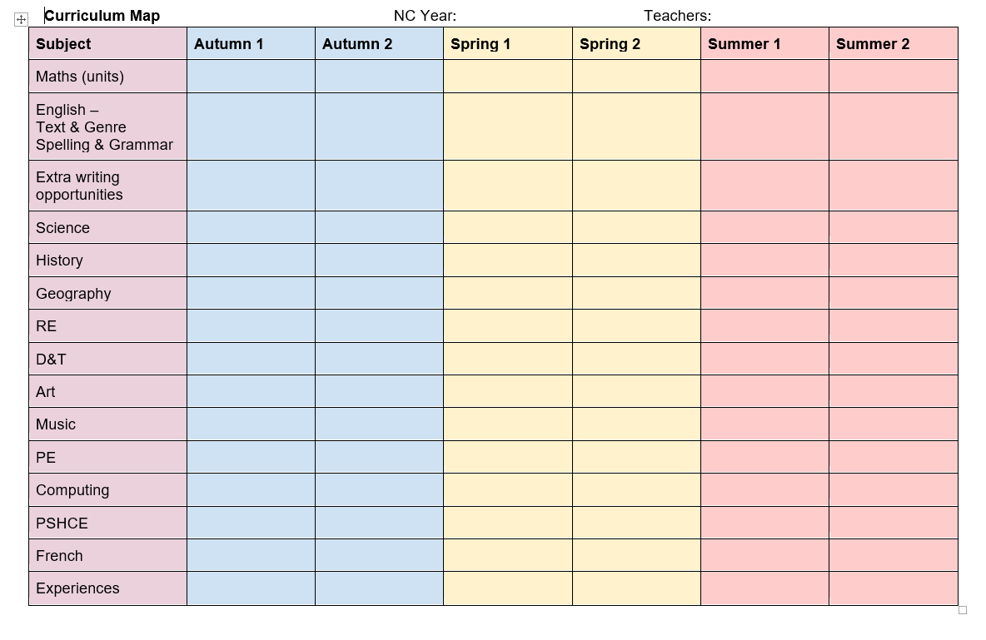

*Curriculum Plan*

# Medium Term

We plan ***a logical teaching sequence which ensures progression from the beginning of the unit to the end****.* This plan will list the learning objectives to be addressed; indicate the learning and teaching activities that are planned in order to achieve the desired outcomes and ensure that the pace of learning is challenging and realistic for all learners.

A medium plan for each core and foundation subject must include the following:

* Learning objective for each lesson
* The learning and teaching activities clearly explained
* Record of how the activity will be differentiated to meet the learners’ needs
* List of key concepts and / or vocabulary
* Identified cross-curricular links

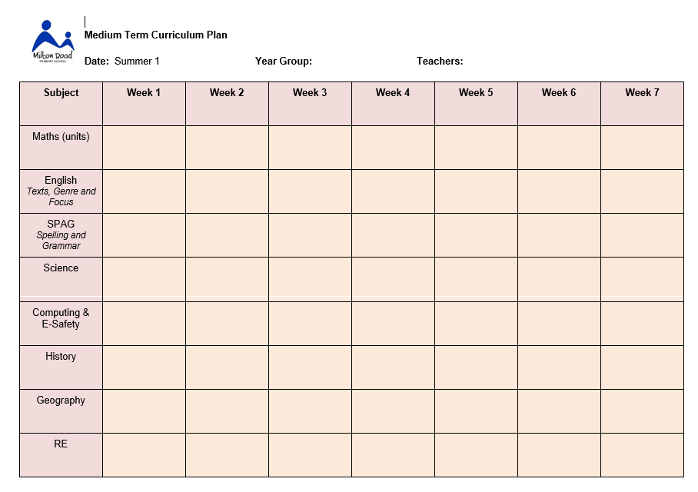

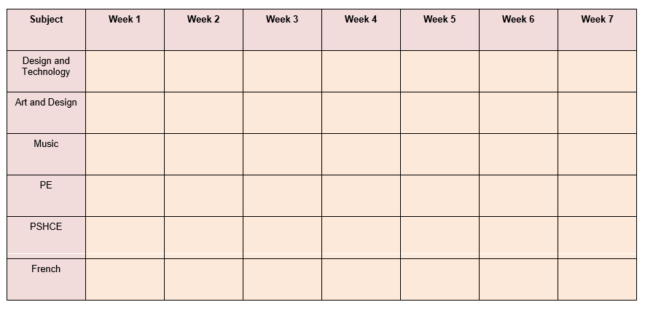

*Medium Term Plan*

# Short Term

We plan for ***pupils’ continuity and progression in learning***, following these non-negotiable features for each English and Maths lesson:

* A concise, de-contextualised Learning Objective
* Success Criteria that are differentiated for pupils’ group work (Extension Level, Core Level and Support Level), guiding them towards meeting the LO
* Key vocabulary and questions
* A mental/oral starter (in maths), main activity, group work (Teacher or TA Guided and Independent) and plenary/mini-plenaries that address pupils’ misconceptions
* Clear role for TA and/or other adults throughout

Please refer to Planning Proformas Appendix 2.

Effective Use of the School Day

# Essential

**No time should be wasted.** Resources must be ready, on children’s tables for them to start purposefully as soon as they get in. The teachers’ Cleverboard should be switched on, with activities ready to go, prior to children entering the classroom.

As children come in **first thing in the morning,** they are expected to settle quickly and quietly, immediately getting started with the first morning activity. Children should understand the expectations and a regular timetable of activities (known the to the children) will support this.

For example:

|  |  |  |  |  |
| --- | --- | --- | --- | --- |
| Monday | Tuesday | Wednesday | Thursday | Friday |
| Handwriting | Quiet Reading | Maths facts | Vocab extension | Responding to Marking |

The weekly timetable should be organised as follows:

* Daily **Maths** lesson, including mental/oral starter,
* Daily **English** lesson
* Daily **Phonics** session (EYFS-Y2)
* Daily **Reading** guided or whole class(one pupil group per day as a guided group; the remainder have mostly English related activities.
* Regular / daily sharing of a **class novel or poem**
* Daily opportunities for children to **read independently** from a self-selected book on their desk (or one from home)
* Two or three opportunities per week for **SPAG** (***or phonics if needed***) in KS2 classes
* Two **PE** sessions per week – one indoor and one outdoor (Premier Sport may lead one of these sessions
* **Daily Mile** each day

Curriculum Topic: The remainder of the time should be shared appropriately to give meaningful and adequate balance to other areas of the curriculum (linked to topics), including history, geography, DT, art, MFL, music, RE.

* Weekly **PHSE** opportunities
* Weekly **Science** lessons, usually 1- 1½ hours in KS2 classes
* At least 2 acts of **Collective Worship**
* Regular opportunities for children to **respond to teachers’ feedback comments** arising from English and Maths lessons, either at the start of the day or the start of the lesson

# Desirable

* Daily **counting** opportunity in EYFS & KS1, *(which could be whilst children are lining up as opposed to a discrete session)*
* Regular **times table and** **mental maths** or ‘Number Talk’ in KS2 classes
* Year groups may choose to focus on subjects such as **Geography, History, RE** for a half term at a time
* More regular (‘little & often’) teaching of Arts subjects: **Art, DT, Music, PSHCE, MFL** can build pupils’ skills effectively over time
* **Class story** is an essential S&L and Reading opportunity. **Show and Tell** is also valuable.
* **Themed days** to enhance and celebrate learning across the curriculum
* Preparations for **performances/concerts**: important to maintain the daily Maths / Phonics / English lessonand to maintain structure / security for the children.

Children’s Workbooks

**Agreed labelling should be used on all children’s workbooks.**

It is the responsibility of the class teacher to ensure that books are stored carefully so that they are kept neat throughout the year

The teacher must explain clearly and directly what the whole school expectation is for neatness of books, children must learn to take pride in the presentation and quality of all of their work. Doodles and inappropriate markings in books by children should be addressed and erased.

Adults must model clear, joined handwriting on lines, on the board, displays and in written work.

Erasers should not be available or used unless sanctioned and allocated by the teacher; one neat line should be used to cross out a mistake.

Rulers must be used for labelling and underlining titles etc.

Marking and Feedback

Feedback comes in a variety of forms and is an essential element of the learning process. It is part of the teaching and learning cycle ensuring that all learners are able to make progress and improve, not just on a single piece of work but in the future also. High quality feedback, both formal and informal, is a regular and essential part of every lesson. Feedback, as in integral part of the learning process, should be specific, clear and appropriate in its purpose, and productive in its outcomes. It must be precisely positioned and positive in tone. The best feedback, whether it is written or verbal, is as immediate as possible and will give pupils a clear sense of how they can improve. For feedback to have the intended purpose, time must be given for pupils to respond to it, allowing them to make progress as a result.

In line with research, staff are not expected to respond to pupils’ work with a certain amount of written feedback, nor are they expected to indicate when verbal feedback has taken place (for example, with a *vf* mark in the margin). The nature of the feedback given to any pupil on a piece of work will be left to the teacher’s discretion and will vary according to the subject and a pupil’s needs at that time. The teacher will judge which form of feedback they deem to be most effective in order to move a pupil’s learning forwards. However, any feedback given to a pupil should result in demonstrable progress. If this is not the case, it is expected that the teacher will reflect on this and alter their feedback approach accordingly.

A key component of the marking and feedback process is the idea of pupil conferencing. This will take place frequently and regularly, between the class teacher and small groups of children (up to 6). During a conference session, children will discuss their work, evaluate their progress and decide together what their next steps might be. For more information on conferencing please see the *Formative Assessment* policy, which also outlines strategies for verbal feedback in more detail; how written feedback can be effective; and how to give meaningful feedback if learning online.

Termly and End of Year Reviews

During the course of an academic year, parents will receive two brief termly reviews (autumn and spring term) and one end of year review (summer term).

The autumn and spring reviews will consist of short bullet points outlining ‘points for discussion’, followed by short, manageable targets (3 or 4) that help pupils move forward in their learning journey. These reviews are sent to parents ahead of the subsequent parents’ evening. In doing so, parents have time to consider your comments and come prepared to the meeting with any responses or further queries. Consequently, the 10-minute slot during parents’ evening can be maximised and the result is a focused dialogue, with the pupil’s best interests at its heart.

Examples of these can be found in Staff Shared/ Annual Reports. Once there, select a class and then ‘Autumn reports’.

Personal and professional conduct

# (Taken from Teachers Standards but applicable to all)

Teachers and other school staff are expected to demonstrate consistently high standards of personal and professional conduct. The following statements define the behaviour and attitudes which set the required standard for conduct.

Teachers and other school staff uphold public trust in the profession and maintain high standards of ethics and behaviour, within and outside school, by:

* treating pupils with dignity, building relationships rooted in mutual respect, and at all times observing proper boundaries appropriate to a professional position
* having regard for the need to safeguard pupils’ well-being, in accordance with statutory provisions
* showing tolerance of and respect for the rights of others
* not undermining fundamental British values, including democracy, the rule of law, individual liberty and mutual respect, and tolerance of those with different faiths and beliefs
* ensuring that personal beliefs are not expressed in ways which exploit pupils’ vulnerability or might lead them to break the law.

Teachers and other school staff must have proper and professional regard for the ethos, policies and practices of the school in which they teach and work, and maintain high standards in their own attendance and punctuality.

Teachers and other school staff must have an understanding of, and always act within, the statutory frameworks which set out their professional duties and responsibilities.”

# Confidentiality

We anticipate that staff will have a high regard for the confidential and sensitive nature of their role and will be mindful of this at all times including formal and informal discussions with parents, other members of staff, children and the wider school community. Particular attention should be paid to confidentiality. Discussions about children/families should be considered to be highly confidential and staff members should always be sensitive and aware of others in the group, room or nearby.

A “needs to know” approach should be adopted to safeguard this principle. Staff should avoid being ‘drawn’ into discussions with others relating to school matters or matters relating to specific children. If there are any concerns in this matter please refer them to the Headteacher or governors. Details relating to children are confidential and can only be shared with staff, as part of their professional role or with the parents/guardians of the child in question. Do not leave confidential records in open places in school or take them home or leave them in your car. Any documents with the names of children, staff or parents must be disposed of in the blue (shredding) bin in the IT Server cupboard.

# Concerns, Suggestions and Feedback

The Headteacher and other senior leaders operate an ‘open door’ policy. They are committed to school improvement and value the ideas of every member of staff. Issues and concerns can be constructively resolved if they are shared with the leadership in a timely and open manner, thus preventing matters from escalating or festering.

Solution Finding and proactivity is a core value of the school’s approach to problem solving. Those closest to the problem are most likely to be able to identify a solution. All ideas are welcome and will be considered carefully.

For the wellbeing of all staff, concerns addressed early on and in a supportive, non-judgemental and open-minded manner, are likely to result in the most positive outcomes for all.

# Team Room

The Team Room is a safe and relaxing space for all staff, visitors and volunteers to relax, un-wind, socialise and liaise professionally. It is a safe space which welcomes everybody and values everybody equally. It is everybody’s responsibility to keep this space clean, tidy and welcoming. It is a room which should be free of clutter and calm. A space where everybody has the right to feel at ease and to take a few moments to unwind. The Team Room space is available for PPA time and non-confidential, professional conversations. It is multi-purpose and sometimes children may work in structured groups within the space.

# Wellbeing

The wellbeing of every, single person in school has never been more paramount. Decisions taken should be mindful of the impact on others time and workload. Children are at the heart of all that we do at Milton Road School, however happy and calm adults are just as fundamental in order to create a positive environment for children to learn.

Some of the strategies we embrace at Milton Road to enhance wellbeing are:

* considering the length and timings of meetings
* opportunities to work from home e.g. in PPA or for subject leader time
* mental health awareness training
* spaces to relax outdoors
* calm, uncluttered spaces
* virtual meetings where staff can join them from home

Wellbeing is an area that we would like to invest in further. If you have any ideas or suggestions then please feel free to share them with the extended leadership team.

Health and Safety

Please report immediately anything you feel is dangerous, to the Head, Deputy or site officer. It is everybody’s responsibility to keep the children, and each other safe. This might include, for example, removing an obstruction in a corridor, mopping up some spilt water or food, putting up a red flag if play equipment is not safe for a child to use.

# Fire Drill

There is a fire drill every term. If the fire bell goes all children (and staff) walk outside, as instructed by their teacher, through the double doors of the classroom. Classes line up in the playgrounds in their designated area. Red, laminated registers should be removed from the classroom doors to the playground on exit. The children’s names should be checked as quickly as possible by the class teacher and then the register should be held up in the air (until told otherwise) to show that the class is all present.

If a child or staff member is not with their class but elsewhere in the school when the fire bell sounds, they should make their way immediately out of school by the nearest door and join their class in the playground. If a child or member of staff is missing from the class, the Headteacher, Deputy or other member of the SLT should be informed immediately. Doors to the school must be closed as soon as the last child has left the classroom. Fire officers will then do a sweep of the school to check that no-one is left behind and internal doors are closed.

In the case of a need for an invacuation (emergency return at haste into school), all staff have been provided with a whistle on their lanyard for alerting staff, parents and children to return to the building as quickly as possible. Repetitive blows of the whistle, accompanied by 5 repetitive rings of the internal bell will signal the need for this emergency invacuation. This will be repeated until everyone is safe inside. This may be for instance if there was a dog on the loose, high winds, storm or at worst an intruder.

On return to the school building the teacher must immediately re-take the register and alert the office if anyone is missing. Doors should be locked and blinds pulled down in the case of an intruder to the site. The police should be called as soon as it is safe to do so. All telephones have 999 access.

# First Aid & Accidents

Janie Jones (TA) is our four-day trained first aider and she is on duty throughout the school day. All of our teaching assistants and midday supervisors have received one-day training. If there is a medical emergency and no first-aider is present, dial 201 for the school office and a first-aider will be sent as quickly as possible. All school telephones have 999 access.

All accidents and treatments should be written in the incident book for each class by first aiders. The top ‘white’ copy will need to be torn off and sent home with any child who receives an injury, however small. A carbon copy will remain in the book. Disposable gloves must be worn when dealing with any bodily fluids. A face mask should be worn for close contact with a child. Gloves should also be kept in the classroom for emergencies there. Parents / carers should also be telephoned immediately if their child receives a severe injury / head bump or damage in or near the eye. The child with the head bump / eye injury will also need to be given a red wrist band to wear to ensure they are monitored throughout the day.

At the end of the school day teachers and TAs should ensure that children do take home their medical slips. This is important and must be a routine part of the day.

A folder of children with special medical needs can be found in the medical room. This contains photographs of the children, alongside their specific protocols.

All Epipens / Antihistamine are stored in clearly labelled plastic boxes (with individual children’s photographs on) in the child’s classroom, in order to ensure ease of access for the child in an emergency If children are going on a school trip or onto the school field ,for example, this box and its contents must accompany the child.

# Medicines

Children may not bring medicines into school. Staff should not administer medicine to children. Please refer to our Medicines in Schools Policy and Children with Medical Conditions Policy on our website. If in exceptional circumstances, a child must take medicine during the day, this must either be accompanied by a proper protocol from their doctor's surgery or a parent / carer must come into school to administer the medicine themselves. Children who need inhalers usually take responsibility for them themselves, alongside a written protocol. In FS & KS1, the class teacher keeps the inhaler in a safe place known to the child and staff. Children who need inhalers must have them with them on the field and close by them on school trips.

# Bicycles, Scooters etc

Cycling is banned on the school grounds, as is the use of scooters, rollerblades and skateboards. Bikes must be wheeled to and from the bike sheds by children. Travelling to school sustainably on bikes, scooters, rollerblades and skateboards is however encouraged. They should be walked / carried into school and stored in the bikesheds or cloakrooms, as appropriate.

# Bars and Climbing Frame

In the KS1 and KS2 playgrounds red flags are used to indicate that equipment should not be used, for example in inclement weather or low staff rations. Equipment must be checked at the start of each break time by those on duty to see if it is slippery and supervision is adequate. The monkey bars (KS1) must be supervised by a member of staff at all playtimes.

# Hot Drinks

For safety reasons, staff must not carry hot drinks around the school or to their classrooms while children are around. Safety cups are available for playground duty or you may bring in your own, with a secure lid, from home.

SAFEGUARDING, WELFARE AND CHILD PROTECTION

# Safeguarding Children

If you have safeguarding concerns about a child or adult of any kind you must alert one of our Designated People (DPs) for Child Protection immediately. You will then be asked to write-up the incident or your concerns on our Child Protection On-line Monitoring System (CPOMs) as soon as possible. The Designated Person will then decide what action should be taken and will seek further advice if necessary. CPOMS is a secure, password protected system which safely stores all files. You will be given training in how to use it. Alerts can be sent to relevant staff and Designated Staff within the system. You may also receive relevant alerts into your e-mail.

If you have any concerns about adults (staff, visitors or volunteers) within school, whether it is their actions or language they are using e.g. extremist or discriminatory, please speak to a Designated Person straight away. Do not confront the person yourself. The school’s Whistleblowing Policy will then be followed.

The Safeguarding Lead for the school is Mrs Nina Burton, with Mrs Rae Snape and Mrs Ali Hall has Deputy Designated Safeguarding Leads. Should all three of these DPs be unavailable then please contact the school office in order for them to be contacted by telephone.

Under the Education Act 2002 (section 175/157) schools must ‘make arrangements to safeguard and promote the welfare of children’. At Milton Road we endeavour to provide a safe and welcoming environment where children are respected and valued. The school will therefore be alert to signs of abuse and neglect and will follow the local Safeguarding Children Board (LSCB) procedures to ensure that children receive appropriate and effective support and protection.

Parents/carers should know that the law requires all school staff to pass on information which gives rise to a concern about a child’s welfare, including risk from neglect, physical, emotional or sexual abuse. The staff will seek, in general to discuss any concerns with the parent/carer, and where possible inform them of the referral to Social Care. This will only be done where such discussion will not place the child at increased risk of significant harm. In accordance with local Information Sharing protocols, we will ensure that information is shared securely and sensitively.

Information will only be shared with other services where it is deemed necessary and proportionate to ensure that children are safe and receive the right service.

Schools will seek advice from Social Care when they have reasonable cause to suspect a child may be suffering or is likely to suffer significant harm. Occasionally, concerns are passed on which are later shown to be unfounded. Parents/carers will appreciate that the member of staff in the school with responsibility for child protection (known as the Designated Person for Child Protection) was carrying out their responsibilities in accordance with the law and acting in the best interests of all children.

# Photographs

Staff must not take photographs of children on personal cameras or phones. The class camera or tablet should be used and all photographs downloaded onto the school system as soon as possible. Please refer to the list of children with photo restrictions given to each class teacher, and held in the office, which identifies which children must not be photographed or their photo used in particular ways e.g. on the website, displays or press. Photographs must never be used on social media and parents are regularly reminded of this. If you have any concerns around this area please speak to the Head or Deputy and refer to our Acceptable Use of ICT Policy and Mobile Phones Policy.

# Behaviour Management

We take a positive approach to behaviour management focussing on building relationships and creating a calm and purposeful environment. Please refer to our Relationship and Behaviour Policy for detailed information on how behaviour is managed in school. For behaviour beyond low level disruption a BEHAVIOUR LOG must be completed on our Child Protection On-line Monitoring System (CPOMs). The Inclusion Manager & Deputy Head will then need to be alerted through this system.

DAILY ROUTINE

# Registers

All staff are reminded that this is a legal document and must be completed at the beginning of each morning and afternoon session. The register should be completed electronically immediately on the children entering the classroom. The register will be completed on paper only if there is a supply teacher in the classroom, or if the electronic version is not working for some reason. Any items for the attention of the office (e.g. return slips) must be sent to the office immediately after morning registration.

The registers should be marked as follows:

those present / for am and \ for pm

those absent N and additionally the code inserted for authorised absences

A list of codes is with the register.

All absence notes should be forwarded to the office. If no note or message is received a phone call home will be made by the office to establish the reason for absence by 9.30am at the latest.

Late arrivals (i.e. those who arrive after the register has been taken) should be sent to the office; here the office staff will enter the appropriate code in to the electronic register, marked with L.

Persistent lateness should be brought to the attention of the Headteacher. Children who are late and arrive after the doors have been locked, should enter via the main entrance where they can be marked in the register at the office. Parents will be asked to sign the late book. It is important that all late children should report to the office to ensure accuracy of the registers in case of emergency

The Education Welfare Officer (EWO) will support us regarding pupils being late/absent; let the Headteacher/Deputy Head know of any issues you want raised with the EWO.

# Lost Property

Parents are asked to name their child's clothing. Lost property is dealt with mainly in classes. Any items not claimed within a reasonable time are disposed of sustainably. Valuable items, e.g. watches are sent to the office.

# Assemblies

Assembly takes place at pre-arrange times in the hall with the Headteacher. Only 2 class bubbles attend and sit socially distanced from each other.

Children should enter and leave the hall for assembly **without** talking. All staff must ensure pupils adhere to this both in and out of the hall. Assemblies focus on many aspects of Social, Moral, Spiritual and Cultural Education as well as British Values. Aspects of these important elements of education and ethos also underpin our PSHEC curriculum.

# Playtimes

Staff will be asked to supervise at playtimes on a rota basis. There is one adult supervising per class bubble. A drink may be taken out in a safe cup with a lid.

Staff Personal Matters

# Illness

Any teaching staff and teaching assistants unable to come to school should please telephone the Office Manager at home by 7am so that cover can be arranged. Midday staff should contact the school office before 10am on the day they are absent. If you know the day before that you are going to be off, it is very helpful to know this the night before. Please ensure you speak in person to your manager to ensure they have got the message as texts / voice mails can sometimes be missed.

In the case of your child being ill, 3 paid absences can be taken throughout the year as long as they are non-consecutive.

In all cases of absence a self-certification form must be completed on your return and a phone call made into school each day, unless there is a doctor’s certificate. A doctor’s certificate is required after 5 days of self-certification. A return to work will also take place with your line manager once you return to work.

# Tea/Coffee

Money for tea and coffee is collected once a term for those who wish to participate or you can bring in your own supplies.

# Lunches

School lunches are available for staff provided by our catering company, Lunchtime Company. Payment must be arranged online through the SIMS Agora system. Please speak to the school office for details of how to subscribe. Packed lunches or cooked lunches may be eaten in the staff room, classroom or dining room.

# Cars and Bicycles

Cars can be parked in the parking bays on the school site. There are two curfew periods when no cars should be moved on site. They are 8.20 - 9.15 and 2.50 - 3.30 Monday to Friday during term time. Bikes may be stored in any of the bike sheds or racks.

# Expenses

Check with the Headteacher or Finance Manager before spending money for school. Expenses may then be reimbursed.

# Orders & Resources

For all classroom resources, an order must be placed with Carol Bretten, the Finance Manager to ensure they are available. Please do not assume we have resources e.g. clay, paints, paper. It is safer to check and then order in plenty of time for your project. We do keep small amounts of coloured paper / card, paint, stationary, books but can’t always guarantee they will be available.

A supply of exercise books, crayons, pencils and other basic stationery is ordered early in June in preparation for the following academic year.

# Entry to School in the Holidays

The school is protected by a burglar alarm. During the school holidays the site officer is on the site for most of the day unless he is on holiday himself. At such times, entry to school can sometimes be arranged with the Head. Please refer to our Lone Working Policy if you think you will be working alone and ensure that a family member / friend knows where you are in case of emergency.

# Working at Height

Staff should not work at height, especially when they are alone. When putting up displays or reaching items high on cupboards, the site supervisor can provide support if asked. Before taking any decisions to work at height, please assess your own and others safety and work with another colleague. If in doubt, ask! There may be an alternative.

Digital Pedagogy

1. Seesaw

# What is Seesaw?

We use Seesaw as a whole school online learning resource to ensure our pedagogy and curriculum is enhancing children's learning and equipping them with the skills necessary to thrive in the modern world.

Seesaw is pupil-driven and operates as a digital portfolio. It is a means to group all resources and activities all in one place for the ease of parents and carers and it offers a safe, secure place to teach children 21st Century skills. Students can add their work through photos, videos, drawings, text and pdfs to evidence their understanding and the tasks they have completed. Teachers can see these posts, gain insight into pupils’ understanding and any arising misconceptions, and share work with families. Seesaw revolutionises the way we communicate with our classes, report to parents, evidence understanding and celebrate our pupils’ achievements.

# Expectations

1. **Seesaw is a communication tool for parents and families**

Teachers are expected to use the communication tool on Seesaw to provide families with weekly updates on their child’s learning. This should be a brief outline of the children’s learning with photos attached of their work/the activities (e.g. role play, outdoor learning, off timetable days e.g. Stone Age Day). Parents may also send messages to teachers which teachers should endeavour to respond to timely, however teachers are not expected to be available in evenings, weekends or during school holidays.

2. **Teachers will provide feedback on work pupils submit on the Seesaw platform.**

Seesaw allows for teachers to mark work as each child completes it. This is essential to ensure Seesaw effectively maintains school connections. Therefore, comments/messages from the teacher (such as praising incredible examples/effort) are expected to ensure children's efforts as a whole are acknowledged and appreciated. We also intend to use Seesaw as a vessel to provide feedback, not marking, but feedback on children’s achievements.

**3. Teachers can use Seesaw to set children learning activities**

Whilst we will be using Century for our home learning provision, you may find you need to set some work on Seesaw due to factors such as sending home personalised interventions. **In the event of school closure, Seesaw will be used to send home work and provide feedback.**

# The Seesaw Interface

Along the journal bar, you will see an activities, inbox and skills section. The inbox allows you to send messages to your class/parents.

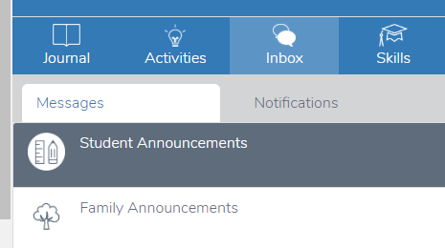

The activities section has a lot to explore. You can view activities currently assigned, ones you would like to assign in the future and past assignments. Not only can you create your own activities, but you can also assign activities from the ready-made resource library.

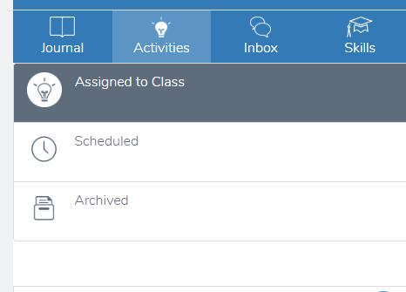

To do this, click 'browse activity library' and you can then filter your search results by age group, subject or topic. Please note that the 'grades' correspond to the American education system and so you will need to 'add a year on' to correspond with the English system.

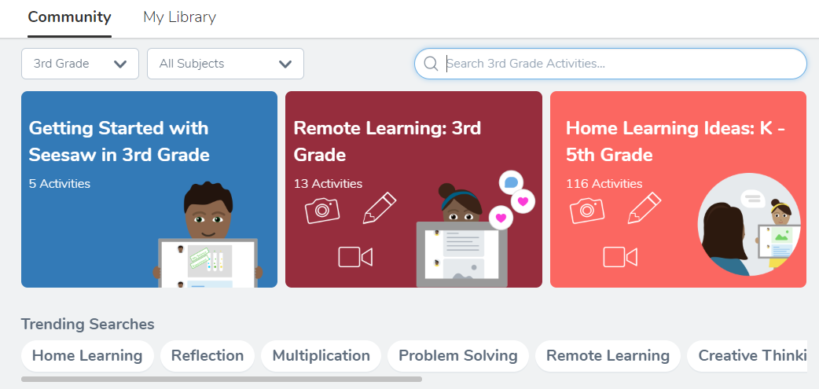

When you see an activity you like, you can favourite it to save it for later or you can assign it to your class now. You can assign it to the whole class or you can make groups and assign it to certain children and assign a different activity to other groups. A separate document, detailing a guide to creating and setting activities, is available.

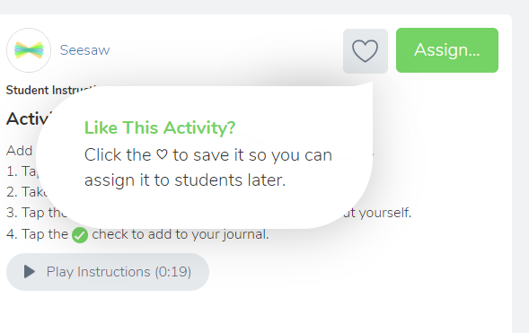

# Communication on SeeSaw

There are two ways to message in Seesaw. Announcements are a great way to reach all families or students in a class, or you can message individuals privately through the Inbox.

Class announcements:

1. To send an announcement, tap the Green Plus+ and select ‘Send Announcement’.

2. Under the ‘Send to…’ drop down menu, select ‘All Students’, ‘All Families’, or ‘All Students and Families’.

You should use this feature to send a message to your class e.g. “Don’t forget to bring your PE kits tomorrow” or to the parents e.g. sharing photos of an exciting activity from the day.

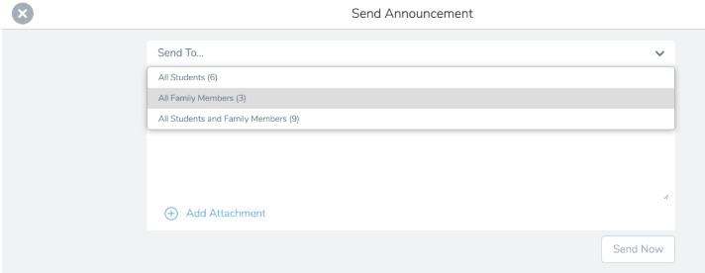

3. Type your announcement. To add an attachment, tap ‘Add attachment’. This is how you add photographs to your posts. You can add a gallery of up to ten photos per post. You can also add video.

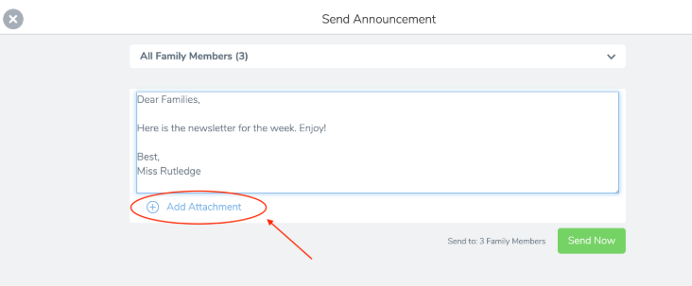

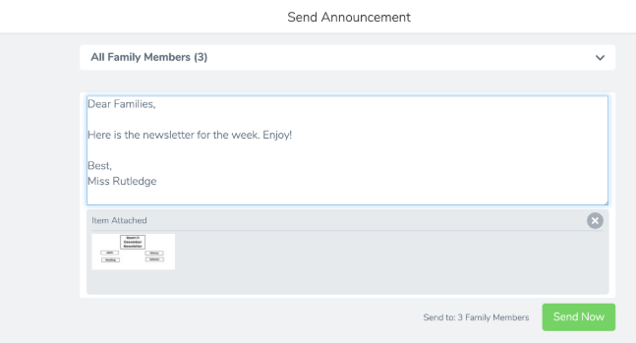4. Tap the green check to add the attachment. Attachments will appear below your text message. To send the announcement, tap ‘Send Now’ on the web, or the green check on the app.

Tap ‘Inbox’ to see all of your messages and replies.  From here, you can send a message to an individual parent rather than your entire class’s parents.

1. To send a private message to an individual family members, tap ‘Inbox’.
2. Tap the name of the family member you want to message.
3. Type your message in the box at the bottom. To add an attachment, tap the blue Add button.
4. Tap the green check to add the attachment. Attachments will appear below your text message. To send the message, tap ‘Send’.



**If a parent messages you, you will see a red notification on your inbox. Click on this to reply to the message thread (rather like a text message)**

1. Century

Century is an online learning platform which uses artificial intelligence to personalise a child’s learning journey based on their attainment and gaps in their knowledge. Pupils will be able to access this system both at home and at school. This system personalises and accelerates learning and enhances teaching by providing actionable data insights and timely, targeted interventions. Pupils will be able to work through resources, tailored to their own needs, at their own pace and this will offer greater insight and flexibility to parents as there is an extensive pool of resources that pupils and parents can access whenever they wish. Whilst the system uses artificial intelligence to set activities and provide feedback, the expectation for teachers is that they closely monitor their class’s use of Century, using the data outputted to identify gaps, inform lesson planning and tailor interventions.

English

# Writing

At the heart of English teaching at Milton Road is the voice of the pupil and their ability to communicate and express themselves. We want children to be happy today, fulfilled in the future and able to make their world a brighter place. By equipping children with the fundamental tools of communication – writing fluently, for purpose and meaning being just one of these – we are playing a huge role in achieving this.

Through high quality, research-driven teaching, our ambition is that children leave us in Year 6 equipped to:

* write independently with confidence, fluency and understanding in order to communicate their thoughts, ideas and responses, knowing that their words have value and they have something worthwhile to share
* understand the power of language and communication as a means of engaging and influencing others
* developing a rich vocabulary in written form in order to accurately express their views
* understand and use a range of text types and genres to write in an appropriate manner in response to a stimulus / situation

Our approach to the teaching of writing develops across the phase groups in order to best suit the children at each point in their writing journey.   
Writing teaching in EYFS and Year 1 is based on a ‘Talking and Writing’ approach, moving towards more of a book-based approach as and when appropriate in Year 1. While many elements of ‘Talking and Writing’ are naturally maintained in Year 2 (and above), writing teaching in Year 2 and LKS2 will largely take the form of a sequence of lessons based around a high-quality text. Again, as and when appropriate, elements of our third approach – Real World Writers – may make their way into these year groups, but the main focus group for this final approach will be UKS2. Additionally, children will also have opportunities to write across the curriculum, for example, their response to a historical event, a DT evaluation or a scientific write-up.

Further and more detailed information on each approach can be found in *Staff Shared / Group / Resources / By subject / English / June 2021 Martin Galway INSET.*

Through a combination of these approaches, we are aiming to inspire children to write for pleasure, purpose and meaning. We believe that all children have a voice, which deserves to be heard. We believe that all children are writers and our job, as educators, is to help them discover this side of themselves.

Maths

In Milton Road, We aim to provide a stimulating and exciting learning environment that takes account of different learning styles and uses appropriate resources to maximise teaching & learning.

The national curriculum for maths aims to ensure that all pupils:

• Become fluent in the fundamentals of mathematics through varied and frequent practice with complexity increasing over time.

• Develop conceptual understanding and ability to recall and apply knowledge rapidly and accurately.

• Reason mathematically; follow a line of enquiry, conjecture relationships and generalisations.

• Develop an argument, justification and proof by using mathematical language.

• Problem solve by applying knowledge to a variety of routine and non-routine problems. Breaking down problems into simpler steps and persevering in answering.

# Planning and Timetabling

Where possible, all classes have a daily mathematics lesson. In key stage one lessons are 45-60 minutes and in key stage two at least 60 minutes. It is encouraged to include a weekly ‘Active’ maths session, where children complete mathematical tasks in a practical, energetic way.

# Long term planning

The National Curriculum for Mathematics 2014, Development Matters and the Early Learning Goals (Number, Shape Space & Measure) provide the long term planning for mathematics taught in the school.

# Medium term planning

Years 1-6 use the White Rose Maths schemes of learning as their medium term planning documents. These schemes provide teachers with exemplification for maths objectives and are broken down into fluency, reasoning and problem solving, key aims of the National Curriculum. They support a mastery approach to teaching and learning and have number at their heart. They ensure teachers stay in the required key stage and support the ideal of depth before breadth. They support pupils working together as a whole group and provide plenty of time to build reasoning and problem solving elements into the curriculum.

# Short term planning

The above schemes of learning support daily lesson/flipchart planning supported by a variety of teaching resources including WhiteRose premium and Maths- No Problem! textbooks and workbooks (where a minimum of one lesson is expected to be taught). EYFS planning is based on the medium term plans and delivered as appropriate to individual children with thought to where the children are now and what steps they need to take next.

Teachers of the EYFS ensure the children learn through a mixture of adult led activities and child initiated activities both inside and outside of the classroom. Mathematics is taught through an integrated approach.

# Assessment

Assessments take place on a termly basis (Autumn, Spring, Summer), using PUMA maths assessments. Questions analysis is then completed Online on ‘Mark’ and the children’s assessed levels placed onto ‘Insight’ assessment.

# Resources

Practical resources are encouraged throughout the school. Everyday items (numicon, deans apparatus, tens squares…) should be readily available in classes for children to collect themselves and assist with their mathematical understanding. Additional practical resources are located in the ‘Maths cupboard’. Many other resources can be found on the school server:

# Whole school planning/maths

Please also refer to the school calculation policy, which is also situated in the maths folder. This takes you through how we teach the various calculations within Milton Road and how it should progress through the school.

# Active maths

Making maths lessons active and practical will help children’s overall mathematical enjoyment, focus and understanding. This is encouraged to be incorporated within our lessons.

PE

**PE** gives chances for children to be creative, cooperative and competitive and to face up to diverse challenges both as individuals and in groups. A 'good workout' helps ease anxiety, tension and stress and will result in improved attention in class.

The national curriculum for physical education aims to ensure that all pupils:

* develop competence to excel in a broad range of physical activities
* are physically active for sustained periods of time
* engage in competitive sports and activities
* lead healthy, active lives

# Planning and Timetabling

There should be two one hour sessions of quality PE per week. One of these can be indoor and one outdoor or both can be outdoor. There will be a hall slot available once a week. A timetable will be sent out each term showing PE times and one will be displayed in the staffroom.

Most of the PE curriculum is prescribed in the New Cambridge Scheme of Work, with supplementary units from the Old Scheme and others provided by external providers e.g. for swimming and cricket. Some Year groups have a unit which links to a particular topic. A paper copy of the New Scheme can be found in a blue folder in the group room of each Year Group. An electronic version of the new and old schemes of work can be found on the school server by following this link:

Staff shared/group/resources by subject/PE

Please see the long term plan below for each Year Group’s Scheme of Work.

# Assessment

At the end of the New Cambridgeshire Scheme units there are assessment grids. These should be photocopied and assessments made for each child at the end of the unit. Names of those children above and below expected can be recorded with all other children assumed to be at the expected level.

# Equipment

Equipment for PE is located in either the indoor PE store within the hall or in the outdoor store to the end of the playground. All equipment should be put back neatly after use from the shelf or area it came from. Please do not keep PE equipment in your classroom. Check the equipment you need is there before your lesson and check to see if balls need pumping up. There is an electronic pump for balls if required; please ask the PE coordinator if you need to use this.

When putting out gym equipment, children can help. They need to be taught how to carry equipment safely – at least 2 to each piece of equipment and walking forwards or sideways and not backwards. The large apparatus in the hall should be put away safely after use. Ask the PE coordinator if you are unsure how to do this.

# Clothing

Teachers should be appropriately dressed for teaching PE.

Children should normally get changed for PE. For indoor gym and dance they should wear shorts and a t-shirt (school uniform) and have bare feet. For outdoor PE children should wear training shoes and can wear a tracksuit for warmth.

Long hair should be tied back and watches and all jewellery removed. If a child has newly pierced ears they can still do PE but not in a contact or group situation.

# Spirit of the games

In PE lessons encourage the children to show six crucial values - Determination, Honesty, Passion, Respect, Self-Belief and Teamwork.

# Active Learning and Playtimes

Making all lessons and break-times more active will help children’s physical and mental wellbeing. ‘Five a day fitness’ within the class and ‘Cross curricular orienteering’ are just two of the ways to make lessons other than PE more active. Young leaders from Y5 and Y6 encourage younger children to play more active games at play and lunch times. Lunchtime supervisors also help to set up games for the children.

# Clubs

There are many clubs available for the children to join both before and after school. Some of these are organised by external providers and some by school staff. If you would like to run a new club for the children or help with an existing one please ask the PE coordinator for more information.

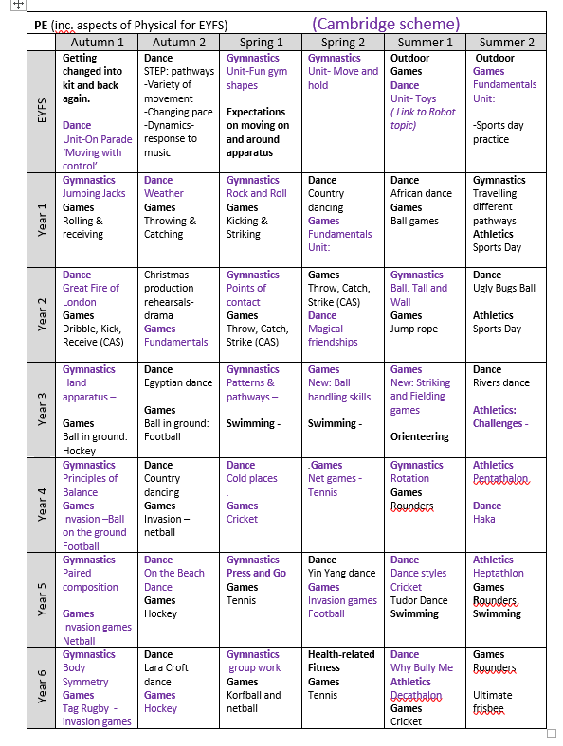

PSHE

Having made your way through the rest of the handbook, you have now arrived at the pivotal section (according to the PSHE leader); the rigorous and regular teaching of PSHE is fundamental to the way our school operates. The six values chosen by our community – Respect, Responsibility, Creativity, Confidence, Curiosity and Kindness underpin our daily lives and we seek to frame our lessons and react to the children’s responses with these values in mind so that we can build a strong moral compass in our community.

We subscribe to the Cambridgeshire Personal Development Programme which provides a planning and assessment framework for the content which became statutory in 2020. We have chosen to operate this on a two year rolling programme to ensure deep coverage (See Appendix 3). This means that KS1, Y3&4, Y5&6 will use the same plans as each other in the pair of years, so planning and resources can be shared to reduce workload. It also gives teaching guidance on areas such as British Values and Prevent, Circle Time and Digital lifestyles.

We have had whole school celebrations such as ‘Kindness Week’ and ‘Empathy Week’ to support our work in anti-bullying and hope that once we are back to having school assemblies and the possibility of more mixing between classes and year groups we will be able to share more projects to support cohesion. We are looking forward to welcoming visitors back into school to share different experiences and ways of inspiring us all.

By the time they complete their Milton Road Primary School years we hope that the children are able to make informed choices to keep themselves happy, healthy and safe and understand what is needed to forge positive and sustaining relationships.

If you have any questions please come and ask Anna-Louise or Tilly who will be very pleased to help.

Early Years

In Early Years we have several non-negotiables. Children must have access to the EYFS outdoor area and a free-flow environment for the majority of time. The environment must be organised and tidy. Everything has a place and there is labelling and shadowing. Activities set up must be as open-ended as possible. The children are encouraged to ‘Choose it, Use it, Put it away’. They must have the opportunity for child-initiated learning for a long, uninterrupted period of time.

The children should be taken on a regular basis to the outdoor classroom. Carpet sessions are of high quality and are carefully planned and expectations are high. We follow two schemes: White Rose for maths, and Story time Phonics. Our themes are based around the children’s’ interests. At the beginning of the year the children have a staggered start according to the needs of the cohort.

The Reception Baseline Assessment is administered in the first six weeks of the children starting school. The adults, who know the children well and know their next steps, plan a broad variety of experiences, as well as planning in the moment. Children who are not on track are prioritised to give all children a secure foundation upon which they can build on in years 1-6.

**Appendix 1**

# Display Non-Negotiables

* Displays should be backed with hessian where available or natural colours. It is the intention that the school has a natural, sustainable and calm feel. ‘Pops’ of colour may be used in a tasteful way.
* Colours should be thoughtfully and tastefully chosen, with an overall ‘look’ in mind. Avoid clutter and distractions.
* Boards must be backed and backing paper should be flat. This should be neatened at the edges with a border.
* Every display must have a clear title (computer generated or cut out). Cursive script should be used as much as possible to promote joined handwriting.
* Work should be attached to the walls using blu tack or staples (not drawing pins).
* All children’s work must be neatly trimmed and evenly mounted.
* Information about what is displayed - e.g. questions, learning objectives and key vocabulary - should be included.
* Work should be thoughtfully positioned within the borders of the display. It should only overlap if there is an intentional artistic reason.
* Work on display should be of a high standard of presentation. Written work should be displayed so that it can be read. Avoid jaunty angles and paper bending.
* Year group displays (in corridors) should be changed every term as a minimum, and reflect different curriculum areas.
* Displays should be checked to ensure they do not become ragged or tatty over time.

*Note: Whilst some practical tasks can be undertaken by TAs, it is the responsibility of teachers to oversee displays. This is to ensure that the learning intention and purpose of every display is planned for and clear.*

**Appendix 2**

# Planning Proformas

Children’s Workbooks

Agreed labelling should be used on all children’s workbooks.

It is the responsibility of the class teacher to ensure that books are stored carefully so that they are kept neat throughout the year.

The teacher must explain clearly and directly what the whole school expectation is for neatness of books, children must learn to take pride in the presentation and quality of all of their work. Doodles and inappropriate markings in books by children should be addressed and erased.

Children are expected from Year 3 to be moving towards a joined, legible style of handwriting in all of their work. This should be encouraged by the class teacher and other adults in the classroom. It should be modelled in front of the class on the board, displays and written work. Once a week handwriting sessions in dedicated handwriting books, as well as complementary sessions in English books will support this. Children will have opportunities to showcase their best presentation in their presentation books each half-term.

Erasers should not be available or used unless sanctioned and allocated by the teacher; one neat, ruled line should be used to cross out a mistake.

Rulers must be used for labelling and underlining.