**Assessment Methodology for PSHE**

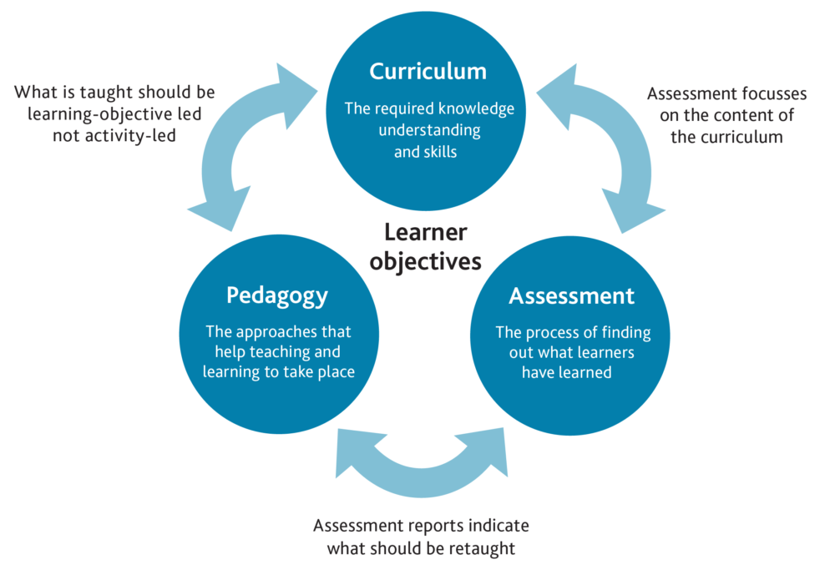

This document has two parts, the first is the general principles of assessment in our school, and the second is the specific methodology for formative and summative assessment in this curriculum subject.

1. **General Principles of Assessments**

**Why is Assessment Important?**

Along with pedagogy and curriculum, assessment is a critical aspect in the learning continuum.

Assessment is very important for monitoring the progress pupils make in the curriculum, including the knowledge and skills that the children have acquired. Assessments help teachers and assistant teachers to plan next steps, to help set targets and goals, report to and involve parents in their children’s learning and most importantly of all to encourage, inspire and motivate children to address misconceptions, to recall and to improve.

There are two main types of assessment: formative assessment and summative assessment. These are sometimes referred to as ***assessment for learning*** and ***assessment of learning***, respectively. At some level, both happen in almost all classrooms.

**Formative Assessments**

Formative assessment takes place on a day-to-day basis during teaching and learning, allowing teachers and pupils to assess attainment and progress more frequently. It begins with diagnostic assessment, indicating what is already known and what gaps may exist in skills or knowledge. If a teacher and pupil understand what has been achieved to date, it is easier to plan the next steps. As the learning continues, further formative assessments indicate whether teaching plans need to be amended to reinforce or extend learning.

Effective formative assessment encourages learning by stressing the importance of recall, critical thinking, reasoning, and reflection thus creating a quality learning environment. Many techniques may be used to formally assess student learning. These include questioning (either directed or no-hands up), concept mapping, writing two or three sentences, the teacher observing (e.g. listening to reading) and recommending specific improvements, low stakes quizzes and so on.

Often formative assessments may not be recorded at all, except perhaps in the lesson plans drawn up to address the next steps indicated.

Assessment for learning is an ongoing iterative process that arises out of the thoughtful and sensitive interaction between teacher and learners.

*“Human Learning presupposes a specific social nature and process by which children grow into the intellectual life of those around them.” Lev S. Vygotsky*

**Summative Assessment**

Summative assessment sums up what a pupil has achieved at the end of a period of time, relative to the learning aims and objectives and the relevant national standards. The period of time between summative assessments may vary, depending on what the subject is and what the teacher or assistant teacher wants to find out. A summative assessment may take place at the end of a unit of work, at the end of a term or half-term, at the end of a year or, as in the case of the national curriculum tests, at the end of a key stage.

Typically summative assessments take place no more than three times a year. The results of summative assessments are reported to parents regularly so that they are fully involved in the child’s learning journey and are able to monitor the progress their child is making at useful intervals over the course of the academic year. To distribute workload and make the summative assessment meaningful, the school provides short termly assessments rather than one long one at the end of the year.

A summative assessment may be a written test, an observation, a conversation or a task. It may be recorded through writing, through photographs that the child takes themselves and shared with families via SeeSaw, through presentation and performance including Expert Showcase, other visual media, or through an audio or video recording. Whichever medium is used, the assessment will show what has been achieved. It will summarise attainment at a particular point in time and may provide individual, cohort and whole school “snap shot” data that will be useful for tracking progress, for informing stakeholders (e.g. parents, governors, etc.) and for defining whole school improvement plans.

To optimise the benefit of summative assessment the outcome data is analysed by teachers inform whole class next steps and teaching and learning (therefore also having formative benefits). The school uses the NFER PIRA and PUMA tests in this way, results are diagnosed to inform formative next steps.

**Recording and Reporting Summative Assessments**

Some summative assessments in the Core Subjects such as PIRA (Progress in Reading and Language Assessment) and PUMA (Progress in Understanding Mathematics Assessment) take place on Insight. For Foundation Subjects, Three Part Assessment Grids are used. Once noted these may be shared with the Curriculum Subject Leader.

The Termly Reports to parents/carers use the same language as the Assessment Grids to inform parents whether their child is Working Towards Age Related Expectation/Standard (ARE), At Expected Age Related Expectation/Standard or Above Expected Age Related Expectation Standard.

1. **Specific Methodologies for PSHE**

|  |
| --- |
| **Curriculum Subject PSHE** |
| **Curriculum Subject Leader Anna-Louise Lawrence** |
| **Formative Assessment Methods**  Formative assessment methods in PSHE might include questioning (either directed or no-hands up), mind mapping, draw and write, worry/ suggestions/ listening box, continuum lines, circle of feelings, partner and group work feeding back to the class. Many of the teaching methodologies provide opportunities for assessment such as discussion carousels, diamond nines (prioritising a set of issues), think-pair-share and jig-sawing (identifying key points in a discussion – groups given different aspects of the same issue, and reporting back). Blogs and discussion boards/forums are also a source of formative assessment as are drama techniques such as hot-seating and role play. Pieces of work suitable for assessment come in many different forms and there is no expectation in PSHE that this must be written work, however short pieces of writing can be a useful opportunity for formative assessment. |
| **Summative Assessment Methods**  Our core teaching is delivered through the Cambridgeshire Personal Development Scheme and at the end of each unit there is a section entitled ‘Processing the Learning’ where we can all reflect on what has been learnt and children have the chance to express what they would like to learn more about. This provides clear assessment opportunities. In PSHEsummative assessment may occasionally be a written task eg at the end of an RSE unit on the changes associated with the adolescent body, children may write a letter from an imaginary child expressing concerns they may have about puberty and then write a response to someone else’s letter. It may be an observation, a conversation or a task. Children may undertake a self-assessment before and after a unit of work. It may be recorded through writing, through photographs that the child takes themselves and shared with families via SeeSaw, through presentation and performance including Expert Showcase, other visual media, or through an audio or video recording.  We believe that PSHE insights are not bound by literacy skills.  There are grids provided at the end of each of the PHSE units in the Cambridgeshire Personal Development Scheme which the teacher can assess by using the age-related expectation descriptors. These are included for teachers to use at their own discretion, as are pupil self-assessment sheets. |
| **Other Notes Relevant to this Subject:** |

References: <https://blog.cambridgeinternational.org/describing-coherence-of-curriculum-pedagogy-and-assessment/>

**Appendix:**

**Example of Three Part Assessment Grid for PSHE**

|  |
| --- |
| **Subject: PSHE** |
| **Learning Objective:** |
| **Example Methodology for Assessment:** |
| **Above Expected Age Related Expectation Standard** |
| **At Expected Age Related Expectation/Standard** |
| **Working Towards Age Related Expectation/Standard (ARE)** |